How to Download Keil uVision and Other Software for Tiva LaunchPad

This tutorial is intended for the first-time user of Texas Instruments Tiva LaunchPad (EK-TM4C123GXL). It covers the downloads and installations of all the necessary software to program the LaunchPad.

The required software components are:

* Keil uVision IDE and RealView MDK v4.54 or newer – You may use other toolchain to develop and program the Tiva LaunchPad. In this tutorial we will only discuss the procedures for Keil toolchain.
* ICDI drivers – Tiva LaunchPad comes with an integrated In-Circuit Debug Interface (ICDI) which allows programming and debugging of the onboard microcontroller. The drivers needed by the host computer to communicate with the Tiva LaunchPad are Stellaris Virtual Serial Port, Stellaris ICDI JTAG/SWD, and Stellaris ICDI DFU.[1]
* LM Flash Programmer – It is a stand-alone utility for programming of the MCUs. The IDEs also use it to program the device.
* TivaWare – a collection of royalty-free libraries for peripherals and code examples.

# Downloads

1. Browse to [www.ti.com/tool/sw-ek-tm4c123gxl](http://www.ti.com/tool/sw-ek-tm4c123gxl).

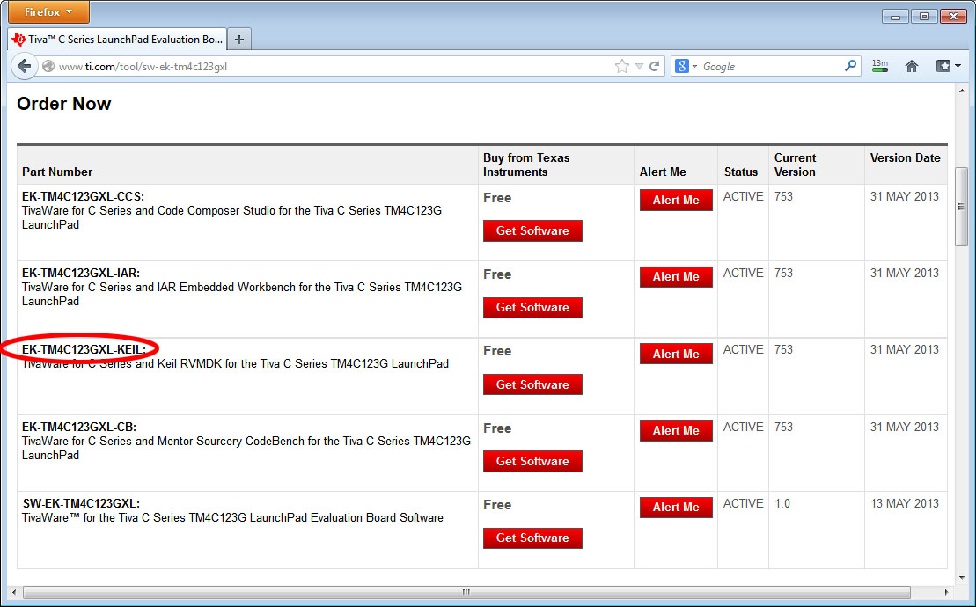

1. If you do not have Keil RealView MDK installed on your computer, **EK-TM4C123GXL-KEIL** will be the choice. It contains all the require software components to program the Tiva LaunchPad. The package is quite large (~500 MB) and will take a while to download. In this tutorial, we will focus on the installation of this software package.
2. If you already have the Keil RealView MDK v4.54 or newer, you may download the rest of the components separately.  
   ICDI Drivers – <http://www.ti.com/tool/stellaris_icdi_drivers>  
   LM Flash Programmer – <http://www.ti.com/tool/lmflashprogrammer>  
   TivaWare (Complete) – <http://www.ti.com/tool/sw-tm4c>  
   There are several different components of the TivaWare. You may download only the ones you need or you may download the complete collection.

# Installations

In this section, we will discuss the installation of the software package downloaded in step 2 above. The downloaded file is **EK-TM4C123GXL-KEIL-753.zip**.

1. Unzip the file and you will have a folder named **EK-TM4C123GXL-KEIL-753**.

The folder contains four subfolders:

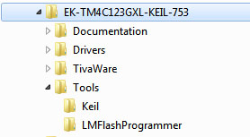

* Documentation – contains the documentation of the board, the device, and the software
* Drivers – the device drivers for the host PC
* TivaWare
* Tools – installation packages of Keil uVision IDE and RealView MDK and LM Flash Programmer

## Documentation

There are n documents in this folder:

**Board\ spmu296.pdf** – the Tiva LaunchPad User’s Guide. It contains the overview, hardware description, software development, PCB layout, bill of material, and schematics.

**Device\ Datasheet-TM4C123GH6PM.pdf** – the datasheet of the microcontroller on the Tiva LaunchPad

**Device\** **errata-TM4C123GH6PM.pdf** – the errata of the datasheet

**Device\ ROM-TM4C123GH6PM-UG-750.pdf** – the TivaWare Peripheral Driver Library and the TivaWare

Boot Loader are programmed into the ROM of the microcontroller on the Tiva LaunchPad. Programmer may take the advantage of calling these functions without having to link the library code into the program, thus reduces the memory usage.

**Quickstart-Driver-Installation-spmu287.pdf** – the device driver installation procedure differs by the operating system of the host computer. This document gives the detailed instruction. A newer version (spmu287b) is also available at ti.com.

**Quickstart-Eval-Kit-Keil.pdf** – this is a tutorial of using Keil RealView MDK with StellarisWare. StellarisWare is the name of the software package now named TivaWare. The procedure is the same for TivaWare but the paths to the folders are different.

**spmu286.pdf** - the sales sheet of TivaLaunchPad

## Keil uVision IDE and RealView MDK

uVision is the integrated development environment (IDE) by Keil. RealView MDK is the toolchain (compiler, linker, debugger, etc.) for developing ARM controllers that runs under the uVision IDE.

1. Open the folder **EK-TM4C123GXL-KEIL-753\Tools\Keil** and you will see a file **mdk454.exe**. Double click on the icon of mkd454.exe. A window will pop up. Follow the instructions in the windows to install Keil uVision IDE and RealView MDK (Microcontroller Development Kit for ARM controllers).

The Keil uVision IDE and RealView MDK will run without a license but the code size is limited to 32K.

## LM Flash Programmer

LM Flash Programmer is a stand-alone application to download the program into the flash memory of the target microcontroller. It is also used by Keil uVision IDE to program the flash.

1. Open the folder **EK-TM4C123GXL-KEIL-753\Tools\LMFlashProgrammer** and double click on the icon of LMFlashProgrammer.msi. It will guide you through installation of the flash programmer.

## TivaWare

TivaWare is a collection of royalty-free libraries for peripherals and code examples.

1. To install it, find the file **EK-TM4C123GXL-KEIL-753\TivaWare\** **SW-EK-TM4C123GXL-1.0.exe** and double click on its icon. It is a simple unzip of the file and stored at **C:\ti\ TivaWare_C_Series-1.0**.

The user’s guides of these libraries are in the downloaded **EK-TM4C123GXL-KEIL-753\TivaWare\docs**.

## ICDI drivers

The ICDI drivers maintain the communication between the host PC and the ICDI on the Tiva LaunchPad. To install them, you need to connect the Tiva LaunchPad to the PC with the USB cable. When Windows found the new hardware device, it will attempt to install the device drivers and failed. You need to go into Device Manager and do update driver and browse to the **EK-TM4C123GXL-KEIL-753\Drivers** folder to find the files for installation.

The procedure differs from Windows XP to Windows 7 and Windows 8. If you are not familiar with Windows device driver installation procedure, please refer to the installation instructions in the downloaded **EK-TM4C123GXL-KEIL-753\Documentation\Quickstart-Driver-Installation-spmu287.pdf**.

When the devices drivers are properly installed, you should see these three devices at the Device Manager:

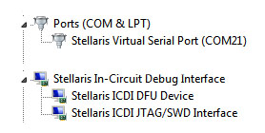

**Stellaris Virtual Serial Port** provides a virtual connection between a COM port of the PC to the UART0 of the Tiva LaunchPad.

**Stellaris ICDI JTAG/SWD** is used to download and debug the Tiva LaunchPad MCU by the host PC.

**Stellaris ICDI DFU Device** is use for Device Firmware Update only when you are using the Boot loader.

# Congratulations

Now you have completed the installation of the development tools. You are ready to write your first program for the Tiva LaunchPad.

1. Stellaris was the family name of Cortex MCUs by Luminary Micro. Luminary Micro was acquired by Texas Instruments in 2009. The name Stellaris remained until 2013 when TI decided to use Tiva to replace it. Although TI made a conscious effort to remove the names Stellaris and Luminary (or LM), they still remain in places.

   The LM4F family devices are renamed TM4C with different part numbers. For example, LM4F120H5QR was renamed TM4C1233H6PM. The part is identical but there are changes needed in software. For details, please see “Migrating Software Projects from StellarisWare® to TivaWare™” (SPMA050A).